Too Much

Curator: Naomi Aviv

An exhibition proposal inspired by Too Much, a book written and designed by Daniel S. Milo, philosopher.

“Too: adv 1. In addition. 2. To an excessive degree. 3. To such a degree as to be regrettable, painful, or reprehensible” (Webster’s Dictionary). English has it right: beneath each ‘two’, a ‘too’ is lurking.
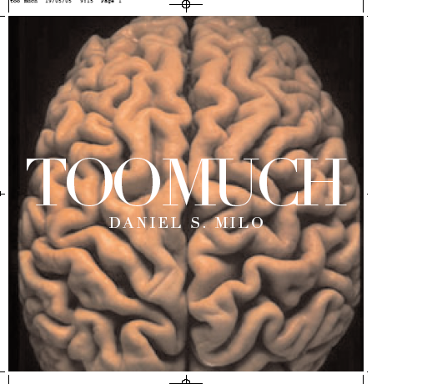

Participants: Amikam Toren, Guy Ben-Ner, Miri Segal, Uriel Orlow, and Daniel S. Milo.

The exhibition will address excess and surplus in a postmodern world. The invited artists propose different models of overlapping, and one-to-one correlation. They all aspire to leave as little as possible “out of the picture.” The overlapping takes place between the work and its representation. Their interrelations —conceptual, epistemological, and ontological— try to reduce the tension between ethics and aesthetics, so characteristic of our postmodern condition.

*

Milo’s Too Much opens like a philosophical children’s fable, telling a story with no distinct “I.” Slowly one discovers that the book’s hero is the human brain.

Our brain is postmodern by nature, Milo argues. Fanatically democratic, it serves as playground to innumerable, heterogeneous, incompatible stimuli. To echo this one-to-oneness, Milo’s tale mobilizes some of the most typical postmodern devices: appropriation, quotation, displacement, simulation, deconstruction. Disregarding in this visual polyphony such fossilized categories as “high” and “low,” Milo has Andy Warhol’s “100 Cans” cohabit with Indian troopers, Dürer’s “Self-Portrait,” a lone drosophila, Breughel’s “Fall of Icarus,” a facsimile of a Flaubert manuscript, a remote-control, and so forth. (For a fuller description of Too Much, see Appendix.)

Yet relativity, pluralism, and “anything goes,” celebrated by postmodernism, are declared here to be Man’s Cross. The moment he wakes up, his eyes open on a jumble. He closes them on the spot: it gets worse. 24 hours a day he is bombarded with data he couldn’t care less about. He strains his ears it’s all buzzing, he opens his mouth: an uproar! The profusion that arises from inside is much greater than what the world outside has to offer. To yield to this siege will irrevocably lead to death, for the point at which all phenomena, external and internal, become equals is called entropy.

One cannot fight the brain’s exuberance without help from the offender itself. Luckily, this wonderful machine complies by submitting reality to draconian measures. It arranges mess and simplifies it, it presses sense on chaos and represses the leftovers; it makes science and art. The most one can accomplish in this continuous drama is a few short stays in havens of order and necessity. Yet the engagement is worth the effort.

I started as a curator in the 80s, at the height of postmodernism. Ever since then, I have operated within this movement—as we all do, for it is the mirror of our brain. Yet I tend to curate exhibitions that respond as best they can to the Danse Macabre and to the defeatism sown by it in contemporary art. The artists and the works that I choose ask themselves a recurrent question: Which human and stylistic values can be relevant to an art that refuses to renounce its role as avant-garde?

My most recent show was Hunger (Tel Aviv, March 2005). In that exhibition, works by thirty artists, Milo among them, addressed the relationship between art and hunger. My options were multiple and tempting: consumerism, gluttony, and bulimia spontaneously sprang to mind. But in the end I opted for a “thin,” minimalist exposition. Hunger dared to deal with the results of famine and non-eating; decline, deterioration, corrosion, fall, agony, and death were dominant within the images and objects shown.

Daniel S. Milo’s Too Much is postmodernism encapsulated – and an antidote against its “poison.” Inspired by this book, I propose an exhibition that endorses Milo’s dictum: “Less, always less!” The four invited artists—Amikam Toren, Guy Ben-Ner, Miri Segal, and Uriel Orlow, as well as Milo himself—challenge overflow. They seek to leave as little as possible “out of the picture;” each of them, within her/his respective techniques and ethos, aims at a full overlapping, or congruency, between representation and object—and invites the viewer to “keep the change.”
The exhibition

Daniel S. Milo continues previous experiences in the field of art. In “A Lesson in Violence” (2000), a performance, Milo and two actors acted out and commented upon violent scenes from Shakespeare’s well-known plays. Some of his projects have been shown in contemporary art exhibitions. “Hunger as Art” (2003) was a piece of video-art inspired by Kafka's “The Hunger Artist,” is one. Milo invites to the viewer is to overcome abstract ideas by “thinking with our own eyes.”

In Too Much, Milo will exhibit the video installation “Between Sofa and Ceiling.” This plastic-philosophical essay, minimalist in its design, comes with the philosophy of Pascal and the temperament of Oblomov. Under six minutes in length, the film features a man (Milo himself) lying on a sofa and gazing at the ceiling. The sound-track is from Blaise Pascal: “All men’s misery has only one reason: they don’t know how to stay at rest, how to keep to their room.” The ceiling gets lower and lower, the man’s stubble grows and grows. With Pascal’s last sentence: “Yet having given it more thought, I have discovered that nothing is as unbearable to man as full respite, without passions, without affairs, without diversions,” the ceiling comes down on the man and crushes him. Reduction is a risky venture, for it rarely stops at 1. One aims at oneness but ends up with less, much less.

The film is shot in color but screened in black and white. The viewer is invited to watch the film while lying on the same sofa seen on screen. Next to the sofa is a modest chest of drawers on top of which lies a copy of Too Much and a reading lamp.

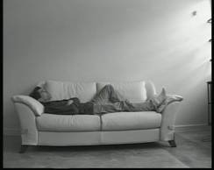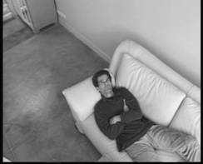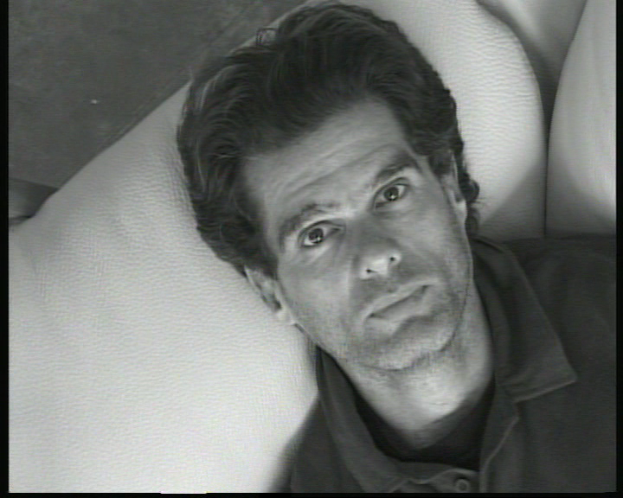
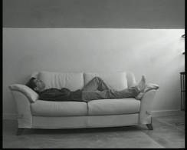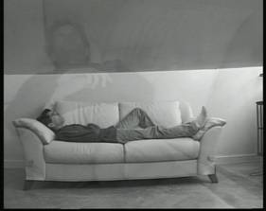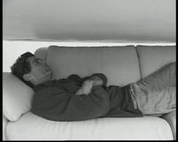
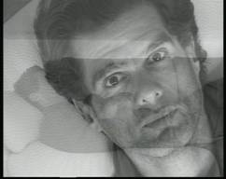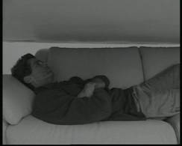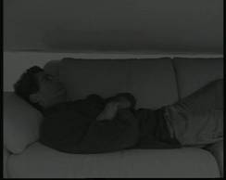

Daniel S. Milo, "Between Sofa and Ceiling"

Guy Ben-Ner is an Israeli artist who lives in New York and is represented by Postmasters Gallery, N.Y. He represented Israel at the 2005 Venice Biennale.

In Too Much, Ben-Ner will show his latest work: “Treehouse Kit,” an installation comprised of a tree and a video. The tree is made of industrial parts; the video features a bearded man (Ben-Ner himself), lying half-naked at the foot of the tree. He brings to mind a man (Robinson Crusoe?) who has just escaped a shipwreck. The man wakes up, discovers the tree, and sets to disassemble it, branch after branch. He discovers that each and every part of this ‘Lego’ can be used to construct a piece of furniture. He starts with a ladder, then moves on to a rocking chair, a parasol, a table and two chairs, and finally a double bed. When his work is done, no piece of wood or screw is left unused. The tree has been dismembered, then recycled, and nothing is left over. Not one thing is de trop. A do-it-yourself manual, the film is screened beside the tree.

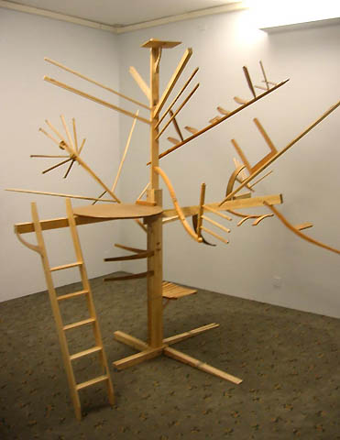

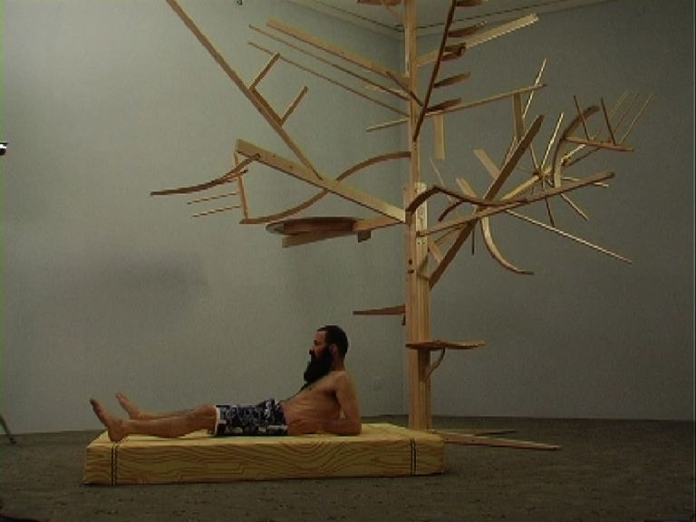

Guy Ben-Ner, “Treehouse Kit”

Amikam Toren is a well known British artist who was born in Israel. In fact, he is the only Israeli-born artist included in Artoday (Phaidon.) He lives in London, and is represented by Anthony Reynolds Gallery.

In this exhibition, he will show three large paintings belonging to his “Pidgin Painting” series. Each one is actually eating itself in order to become a painting, nothing else but a painting. Toren, as conceptual and essential as ever, tries to achieve a painting that deals with the representation of a painting, by using only the means of painting. He stretches a large canvas and "bites off" swaths of fabric. Then he pulps—in a grainer!—the pieces of canvas, mixes them with a clear binder, and applies the result as ‘paint’ to the remainder of the stretched canvas. We witness then a perfect trope of the ultimate self-reflexive painting: an abstract painting which is at the same time a representational painting. Tautologically, it is a painting of a painting, made from a painting, as well as a picture of the process of its own creation, paradoxically made possible through its own destruction. His skeleton work is the purest demonstration of painting as painting, of art becoming what it stands for.

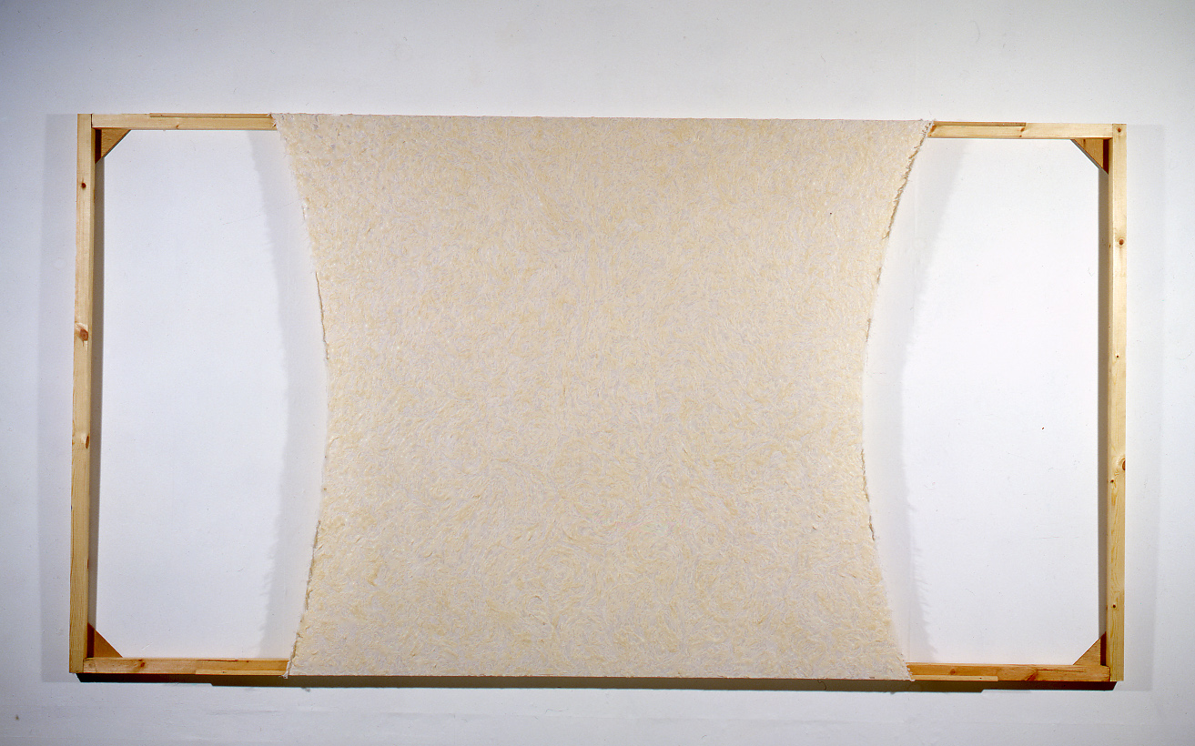

Amikam Toren, “Pulped canvas,” PVA and pencil
on canvas, on stretcher, 180x339cm

Miri Segal lives and works in Tel-Aviv. She has a Ph.D. in mathematics from the Hebrew University of Jerusalem, Israel. Solo exhibitions include “Interfaces” (Tel Aviv Museum of Art, 2002); “Circular Acts” (P.S. 1 Center of Contemporary Art, New York); “Thin Skin” (ICI, AXA Gallery, New York, and traveling through USA and Europe, 2002). Exhibitions in 2004 included the group show “Re-Search” (List, MIT, Cambridge) and a solo exhibition at Dvir Gallery, Tel Aviv. Segal’s main concern as an artist is the relationship between perception and technology.

She will display a new version of an early work, “Untitled” (1999). As a work in situ, this video projection appropriates one of the gallery corners. Segal places the video projector in front of the same corner documented by the camera. The image of this corner is projected on top of the corner itself. Between the representation and the represented is then enacted an almost one-to-one correlation. And yet, the projected image seems to vibrate as if trying to fit in the exact borders of the actual corner. The effect of an animated object fighting its way ‘home’ is reinforced by the soundtrack: breathing as rhythmic as the sea's.

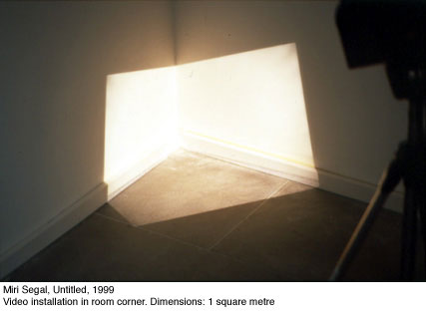

Uriel Orlow. Born in Zurich, he lives, creates, and teaches in London. In 2002 he completed a Ph.D. in Fine Arts. He has been featured in international exhibitions and film festivals and his work is represented in a number of private and public collections.

In Too Much Orlow will exhibit “Housed Memory,” a project developed as part of the Year of the Artist at the Wiener Library, London, in 2000. The Wiener Library began as a collection tracing the development of Fascism and anti-Semitism in Germany in the early 1930's. In 1938 it was moved to London, where the archive continued to grow. Using video, photography, text, and sound, Orlow records and collects what is there: ‘the given’. With the aid of simple yet compelling methods, his work evokes something else yet present, thus addressing complex structures and meanings with philosophical and ethical resonances. Repetition and gesture are recurring tropes that place the works between action and image, movement and representation. The project consists of three independent, yet related works. Nine hours long, it constitutes a video archive of all the contents of the Library. An endless but discontinuous tracking-shot reveals and records, shelf by shelf, the document that is the archive itself, portraying the contents of an extensive historical, political, and cultural archive otherwise only visible to those working in the Library. In so doing, the camera takes on the role of an historical witness and the video itself becomes an independent documentary. Whoever joins this exhaustive journey will gaze at all those unread (by him) documents and feel empty and ignorant. Or relief ...

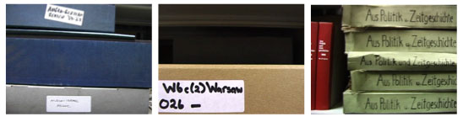

Uriel Orlow, “House Memory,” 9 hours
Appendix

Too Much (TROP)

Daniel S. Milo has published seven books, among them Betraying Time (Trahir le temps, 1991), an exercise in experimental history that impoverishes the past and its vestiges; and The Brain Bearers (Les Porteurs de cerveau, 2004), a Sci-Fi novel in which the N.I.E.T—New Institute for EThical engineering—puts all of humanity on a diet: writers and film-makers are forbidden from inventing new characters, cat-lovers have only three races to choose from, fewer and fewer brands of cereals are to be found on the shelves, all but three sexual positions are legally prohibited, only two among the hundreds of available psychotherapy techniques are permitted …

Too Much displays Brain’s techniques in handling excess. As someone who lives by his word, Milo uses language that is rich and lyrical; but he also taps into an inexhaustible stock of connotations and associations from different realms. Here he combines his unique writing style with ready-made images that move freely from museum to laboratory to kitchen and back. Among these images are reproductions of works by Mondrian, Turner, Géricault, Chardin, Bosch, and Cranach, as well as Beuys, Andy Warhol, Sylvie Fleury, and other contemporary artists. But Too Much being also the illegitimate daughter of the Internet, those art-works appear alongside an eclectic panoply of images: two demographic maps, an MRI of a brain afflicted with Alzheimer’s, a detailed sketch of the evolutionary tree, a close-up of Francis Bacon’s iris, Freud’s couch, an assortment of Ecstasy pills.

Each of the book’s pages triggers thinking that moves among different areas in the cerebral cortex, and some aim even deeper, to the limbic brain if possible (the reptilian one being beyond reach). The dialectic movement between word and image produces an experiential comprehension of ideas whose formulation in words alone would not extract from the reader the same physical internalization of an abstract idea.

Each page may have an autonomous life, and on each page, text and image could be experienced separately, yet these the verbal and the visual are linked by a constant, tangible thread. For this is no illustrated book in any conventional sense. The image no more illustrates the text than the text illustrates the image, and their overlapping, page after page, generates a new plane—the plane on which art occurs.

